Answer 9
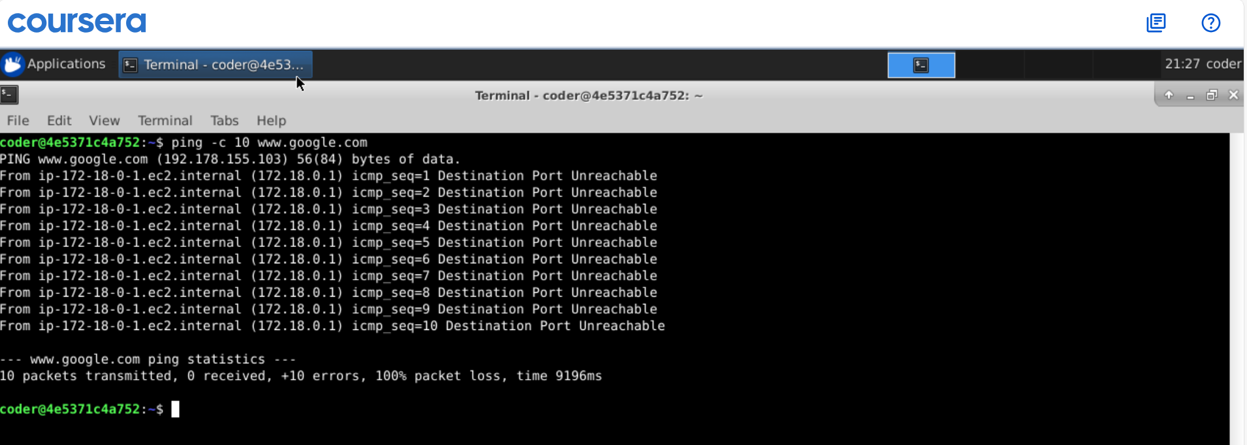
Explanation: So, we tried running ping command which -c option sending 10 requests to www.google.com, but at the end it shows we receive nothing. Also, it says destination port unreachable which show we don’t have network connectivity.

